WATER AND SANITIATION AGENCY (WASA)

To:

Sir,

APPLICATION FORM – NEW WATER CONNECTION

In charge
Application No.
Date:
New Water Connection
WASA JHELUM

- I hereby request for sanction and installation of new water connection. My Particulars are as under:
  - PERSONAL
    - Name b. Father’s Name
- CNIC# d. Telephone NO.
e. Address
  - PARTICULARS OF PREMISES
    - Type of premises b. WASA (W) No.
- Size of Plot. (merles) d. Covered Area Sq. Ft
- Address:
- Type of connection (domestic/commercial)
- Size of connection h. Distance from Distribution pipeline
  - Availability of underground/overhead water tank

j. Extent of road cut involved (if any)

- I hereby attach the attested copies of ownership Proof. NIC. site plan and self-addressed envelope.
- I hereby undertake to:
  - Deposit new connection fee and allied charges on WASA Demand.
  - Accept existing quantity / pressure of Water Supply at site.
  - Pay may water bills regularly.
  - Abide by the Rules and Regulations of WASA and WASA shall have the right to disconnect the connection without notice and to take legal action in case of nonpayment of water charges or for any other default on my part.
- It is certified that the above information is correct to the best of my knowledge and I shall be liable to legal action. If the above –mentioned information is found incorrect.

Date: Signature of applicant

FOR OFFICIAL USE
RECEIPT
Received Application No. Dated from Mr./Mrs. for new water connection
Date:

Signature of official

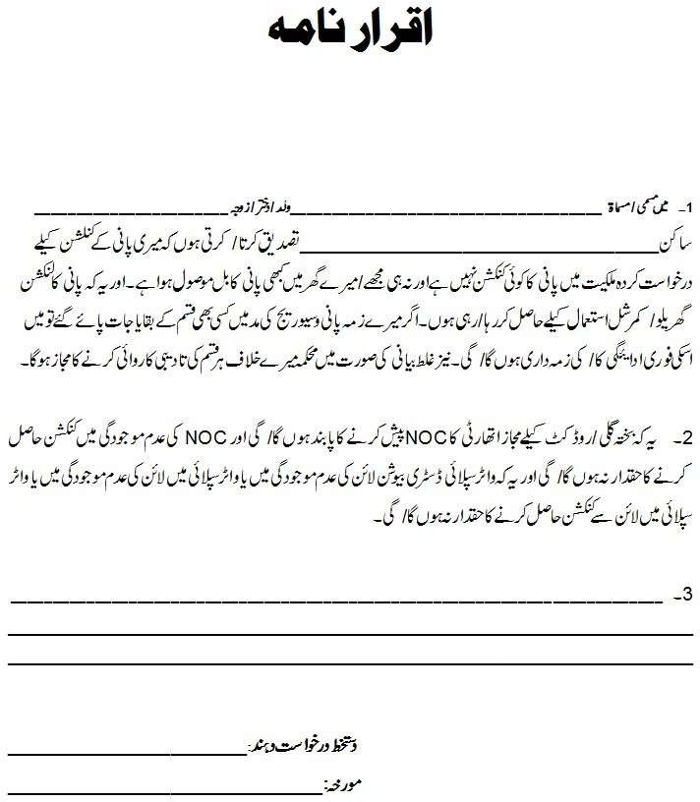

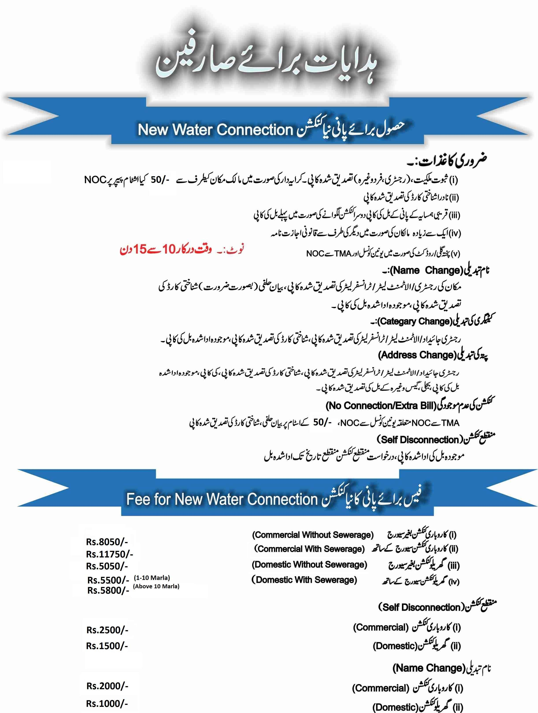

Connection Charges
Domestic

Sr.No | Category | Water | Sewerage | Total
1 | 1 Marla to 10 Marla | 800 | 1200 | 2000
2 | 11 Marla to 20 Marla | 1200 | 2000 | 3200
3 | 20 Marla to Above | 1200 | 3000 | 4200

Commercial
Sr.No | Category | Water | Sewerage | Total
1 | 1 Marla to 10 Marla | 1000 | 4000 | 5000
2 | 11 Marla to 20 Marla | 2000 | 6000 | 8000
3 | 20 Marla to Above | 2000 | 8000 | 10000
Industrial
Sr.No | Category | Water | Sewerage | Total
1 | 1 Marla to 10 Marla | 1000 | 10000 | 11000
2 | 11 Marla to 20 Marla | 2000 | 12000 | 14000
3 | 20 Marla to Above | 2000 | 14000 | 16000
Plaza
Sr.No | Category | Water | Sewerage | Total
1 | 1 Marla to 10 Marla | — | 10000 | 10000
2 | 11 Marla to 20 Marla | — | 20000 | 20000
3 | 21 Marla to 30 Marla | — | 30000 | 30000
4 | Above 30 Marla | — | 50000 | 50000

Disconnection and Reconnection Fee

Sr.No | Category | Existing Disconnection / Reconnection | Revised Disconnection Fee | Revised Reconnection Fee
1 | Domestic | 200 | 500 | 500
2 | Commercial | 200 | 1000 | 1000
3 | Industrial | 200 | 2000 | 2000

